Alphawave Solutions

(Group 4)

Meet the Team

1. Harsh Sachala – 110124409
2. Smita Khristi – 110128509
3. Rahul Patel – 110128309
4. Vatsal Sakalshawala – 110127726
5. Arjun Patel – 110128643
6. Baushil Shah – 110126216

Mentor :- Lavanya Nagarajuna

**The goal for the past sprints/iterations since the last report.**

In the past sprints or iterations since our last report, our primary focus was to complete the front-end development with logging requirement part with all possible functionality. Alongside this, we also worked on developing the backend APIs. These APIs are crucial for enabling communication between the front end and the back end, and we made sure they were robust and ready for integration.

Once the frontend and backend components were in place, our next step was to integrate them and test the APIs with Postman. We have almost started out testing for APIs In the last sprint as we faced some difficulties for implementing some backend functionality like for eg. Email sending functionality was throwing errors we then made a fix and it is now working hence that took a bit time.

Parallelly, we worked on developing the machine learning model. Initially, we used YOLOv7 for this purpose, also after a meeting with our mentor, we decided to upgrade to YOLOv8 to take advantage of its improved features and capabilities. so we have worked on thousands of images to train model and come up with the final product. And we have also deployed a initial model with a separate single page application for testing the model on web interface which will then be integrated in the final app altogether hence the testing and deployment of the model is also going alongside the inventory management dashboard

**What product backlog items are contributed toward the sprint/iteration goal? user stories should be written as the given template: As a < type of user >, I want < some goal > so that < some reason >**

1. **Bug Fixes**
   * **User Story:** As a user, I want the application to be free of bugs so that I can have a seamless experience.
   * **Tasks:**
     + Identify and document bugs.
     + Implement fixes for reported bugs.
     + Test to ensure bugs are resolved.
2. **APIs of Product and Contact Us**
   * **User Story:** As a developer, I want reliable APIs for the product and contact us page so that I can access and send data efficiently.
   * **Tasks:**
     + Design and develop Product API.
     + Design and develop Contact Us API.
     + Test the APIs for functionality and performance.
3. **Frontend Related Pages**
   * **User Story:** As a user, I want intuitive and responsive frontend pages so that I can easily navigate and use the application.
   * **Tasks:**
     + Design the layout and user interface.
     + Implement the frontend code for various pages.
     + Conduct usability testing and make necessary adjustments.
4. **Model Training**
   * **User Story:** As a data scientist, I want to train the model on new datasets so that it can improve its accuracy and performance.
   * **Tasks:**
     + Prepare datasets for training.
     + Train the model using the latest data.
     + Evaluate and tune the model for optimal performance.
5. **Data Annotation**
   * **User Story:** As a data scientist, I want accurately annotated data so that the model can learn from high-quality inputs.
   * **Tasks:**
     + Annotate new datasets.
     + Review and validate annotations.
     + Integrate annotated data into the training pipeline.
6. **Weekly Sprint Planning**
   * **User Story:** As a team member, I want to participate in weekly sprint planning so that we can align our tasks and goals.
   * **Tasks:**
     + Conduct sprint planning meeting.
     + Review and prioritize backlog items.
     + Assign tasks for the upcoming sprint.
7. **Weekly In-Person Meeting**
   * **User Story:** As a team member, I want to attend weekly in-person meetings so that we can discuss progress and resolve issues collaboratively.
   * **Tasks:**
     + Schedule and prepare for the meeting.
     + Discuss sprint progress and blockers.
     + Plan actions to resolve issues.
8. **Testing of API**
   * **User Story:** As a tester, I want to thoroughly test the APIs so that they function correctly and meet requirements.
   * **Tasks:**
     + Create test cases for API functionalities.
     + Execute tests and document results.
     + Report and fix any issues found during testing.
9. **Initial Integration**
   * **User Story:** As a developer, I want to perform initial integration of various components so that the system works as a cohesive unit.
   * **Tasks:**
     + Integrate backend APIs with the frontend.
     + Ensure data flows correctly between components.
     + Test the integrated system for basic functionality.
10. **Model Testing**
    * **User Story:** As a data scientist, I want to test the trained model so that it performs well on real-world data.
    * **Tasks:**
      + Test the model using a separate validation dataset.
      + Analyze the model's performance and identify any issues.
      + Make necessary adjustments to improve accuracy.

**Current Sprint is Development 4**

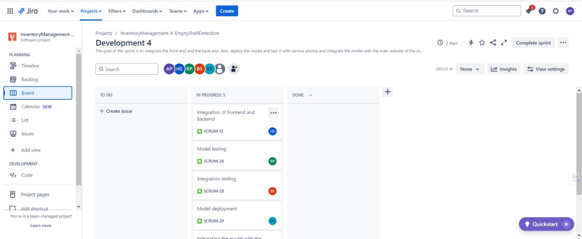

**Past sprints**

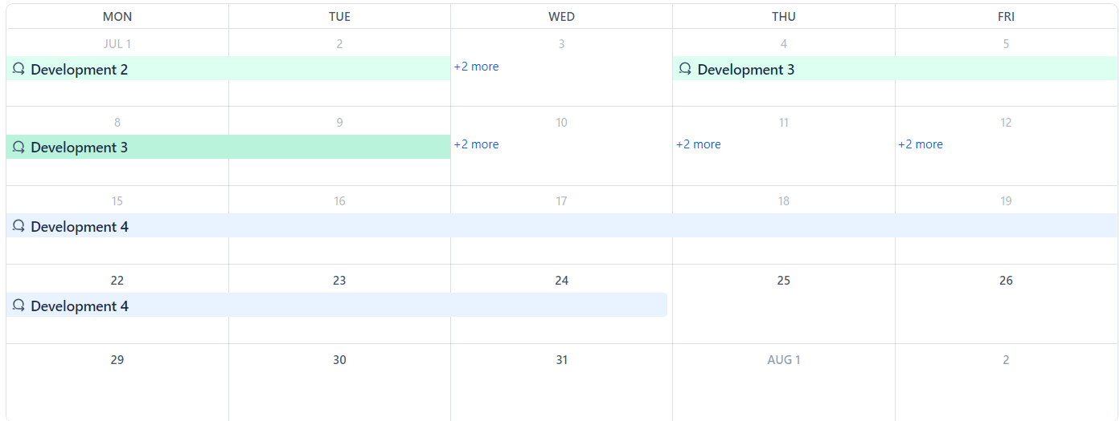

**Tasks for each user stories.**

In our project, we have outlined six main user stories, each critical to the development and success of our application. To ensure clarity and organization, we've broken down the specific tasks required for each user story. This structured approach not only facilitates precise project management but also enhances collaboration among team members. Below is detailed the tasks associated with each user story,

1. Training AI Model

- Collect and preprocess a diverse dataset.

- Choose and configure the machine learning algorithm (e.g., YOLO7 for image recognition).

- Train the model using the prepared datasets.

- Evaluate the model's performance and optimize parameters.

- Document the training process and outcomes for future reference.

2. Designing and Completing All Functionalities of the Frontend

- Sketch initial design mockups and get team feedback.

- Develop interactive elements and user interfaces using front-end technologies.

- Implement responsive design to ensure compatibility across different devices and screen sizes.

- Test frontend components for usability and fix any issues.

- Finalize all user interface elements and ensure they meet the project’s requirements.

3. Developing Backend

- Set up server, databases, and APIs necessary for the backend infrastructure.

- Develop functional logic to handle requests, process data, and communicate with the frontend.

- Implement security measures, such as authentication and data encryption.

- Test backend functions to ensure they work as expected and fix any bugs.

- Document the backend setup and functionalities for maintenance and future updates.

4. Integrating Frontend with Backend

- Ensure all API endpoints are correctly designed to meet frontend requirements.

- Test integration points extensively to handle data correctly between frontend and backend.

- Optimize load times and data handling between client and server.

- Resolve any integration issues that arise during testing

5. Testing

- Develop and execute test cases covering all functionalities.

- Perform unit testing, integration testing, and system testing.

- Use automated testing tools where applicable to ensure broad coverage.

- Document all testing procedures and results.

- Address and resolve any defects or issues found during testing.

6. Making Report of All Activities

- Compile documentation of each phase of the project, including challenges and solutions.

- Track progress and milestones against the project timeline.

- Create a comprehensive report detailing the development process, testing outcomes, and project learnings.

- Review the project report with the team and stakeholders to provide insights and gather feedback.

**Estimated value of story points/velocity**

our project was divided into four major parts, with each segment involving significant tasks. The major tasks were preparing a model, integrating the front end with the back end, and implementing email functionality. The preparation of the model was particularly resource-intensive, requiring around 14 hours of computation time. These tasks were challenging and demanded a substantial amount of effort and coordination. In addition to these larger tasks, our team also tackled smaller-scale tasks such as implementing the front end and testing API functionality. These were less complex but still crucial to the project's success.

To manage and evaluate the team's work, velocity estimation is 5. Each member could contribute effectively and support each other. The equal contribution from all team members was vital, allowing to collaborate efficiently and meet project deadlines. Our approach not only facilitated a well-organized workflow but also fostered a supportive team environment. This strategy was essential in tackling both the extensive and demanding tasks and the smaller, though no less important, aspects of project.

**Identified Risks and mitigation plan**.

During our project, we encountered a significant challenge in the backend development, specifically with setting up email functionalities, which stalled our integration of the backend and front end and also paused our testing phase. Additionally, overlapping deadlines from other courses created external pressures.

To mitigate such issues in the future, we plan to improve our internal communication and get help from a mentor as well in an early phase. This approach will ensure that potential roadblocks are addressed promptly before they escalate. By sharing challenges immediately, we can pool our collective expertise to find solutions more quickly.

For external challenges like overlapping deadlines, we'll enhance our time management and prioritize tasks to better handle academic pressures. This will involve setting clearer milestones and possibly adjusting our project timeline to better align with academic deadlines, ensuring that we do not face undue stress towards the end of the semester. These steps are aimed at ensuring smoother project execution and minimizing disruptions, thus maintaining our focus on delivering a successful project.

**How does the team divide the tasks among members?**

When we started the project, we set up our team into four distinct groups, each handling a different part of the work. This way, everyone knows exactly what they’re responsible for, which helps us get things done smoothly and efficiently.

At the beginning of our project, we organized our team into four main groups, each with its own specific responsibilities, each handling a different part of the work. This way, everyone knows exactly what they’re responsible for, which helps us get things done smoothly and efficiently. Vatsal and Rahul are focused on managing the database and training our machine-learning model. They work on designing how data is stored and accessed, and they fine-tune the model to ensure it performs well.

Smita and Arjun are in charge of the front end - work on designing and building the user interface to make sure it’s easy to use and looks good. While Harsh handles the backend - managing servers, databases, and application logic to ensure everything runs efficiently and securely. Baushil is dedicated to testing the project - finding and fixing any bugs or issues before the product goes live, ensuring that everything works as expected.

Although we each have our own areas of focus, we all collaborate and help each other out when needed. If someone runs into a problem or needs additional support, the rest of the team pitches in to assist. This collaborative approach helps us stay on track and resolve issues quickly, making sure the project progress smoothly.

**A complete discussion on what went well, what went poorly, and opportunities for improvement to the product or ‘shipped’ process.**

In our last period since meeting with the GA during reading week, our efforts have increased dramaticlly, particularly in the area of model building. Our data team used thousands of images to train a model using YOLO7, which then required a continuous 14-hour period to build. This phase of the project was executed at a rapid pace by our data team.

As for the layout and development aspects, the frontend was initially set up, but many functionalities were still incomplete at that time. From that point until our last meeting with the GA, we completed every feature of the frontend. Backend development began in weeks 7 and 8. Unfortunately, we encountered significant delays during the integration of the frontend with the backend, primarily due to persistent errors that prevented us from setting up the email functionality in the backend. This issue became a major as we were stuck on it for several days. Parallel to resolving the backend issues, we continued to work on our APIs, utilizing Postman to initiate testing and begin drafting basic reports. We also addressed some bug fixes during this time.

Overall, the frontend development and model training phases of our project proceeded smoothly. The main challenge we faced was the backend error related to email functionality, which significantly hindered our progress. Moving forward, we recognize the need to engage more deeply in troubleshooting such issues promptly. Addressing challenges swiftly will be our main opportunity for improvement, ensuring smoother integrations and more efficient progress in future projects.

**What is your team’s plan for the remaining weeks of this semester ?**

For the remaining weeks of this semester, our team is primarily focused on testing and comprehensive reports on our findings. Additionally, we will be dedicating a portion of our next sprint to refining the backend mainly focusing on integrating the trained tested and deployed model with the dashboard of inventory management app. Although we have completed the development of the data model and frontend functionalities, we will review these components one final time to confirm everything is in order. Last but not least, our efforts will be the final integration of all components to deliver a successful product. This phase will be crucial as it will validate the robustness and readiness of our application for deployment. And Finally we will deploy our product to the website. Hence the next steps are deployment and integration along with testing.

**Relevant screenshots**

**Data annotation and model training by Vatsal and Rahul**

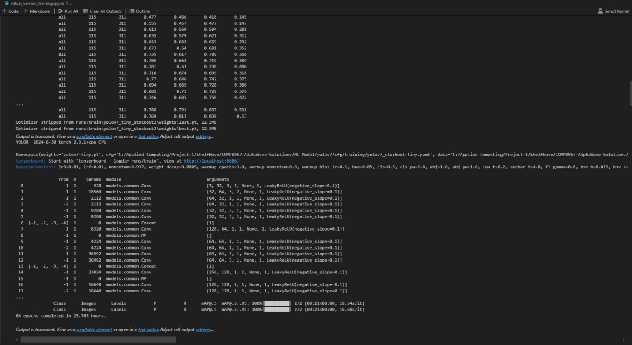

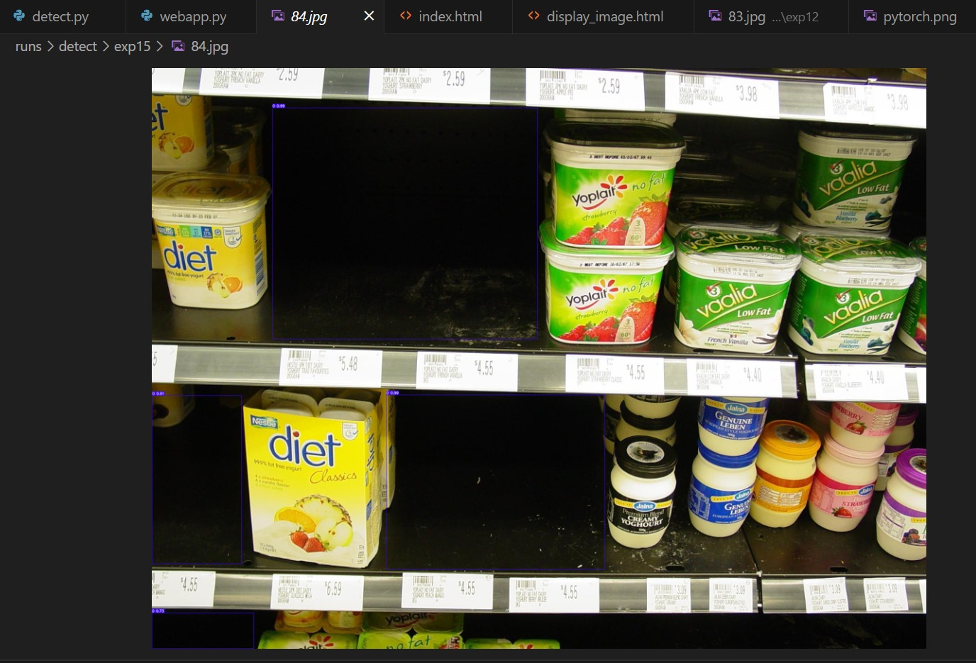

**Initial deployment of the model by Vatsal**

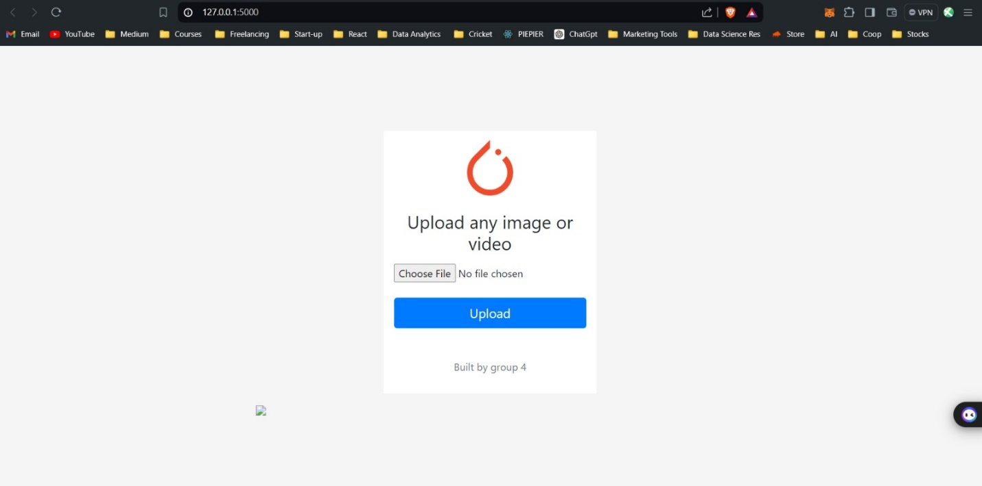

**Frontend pages by Smita and Arjun**

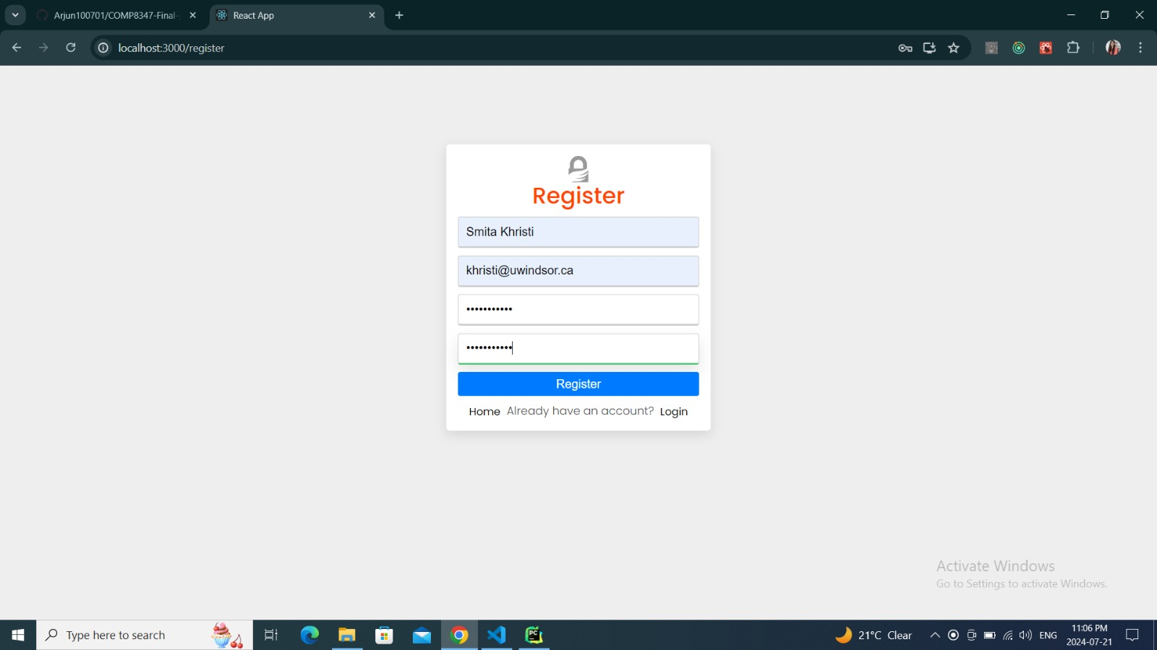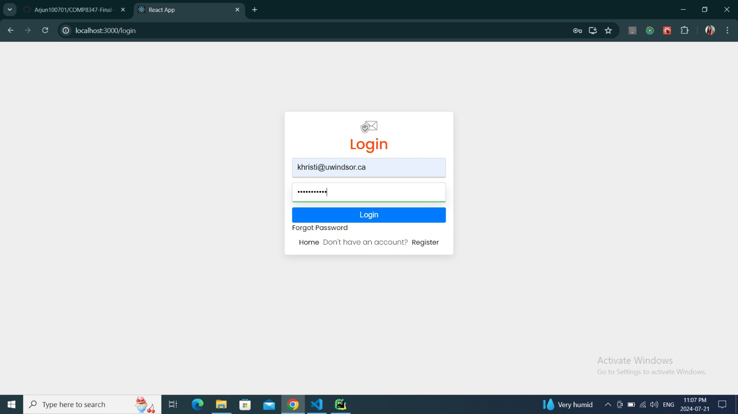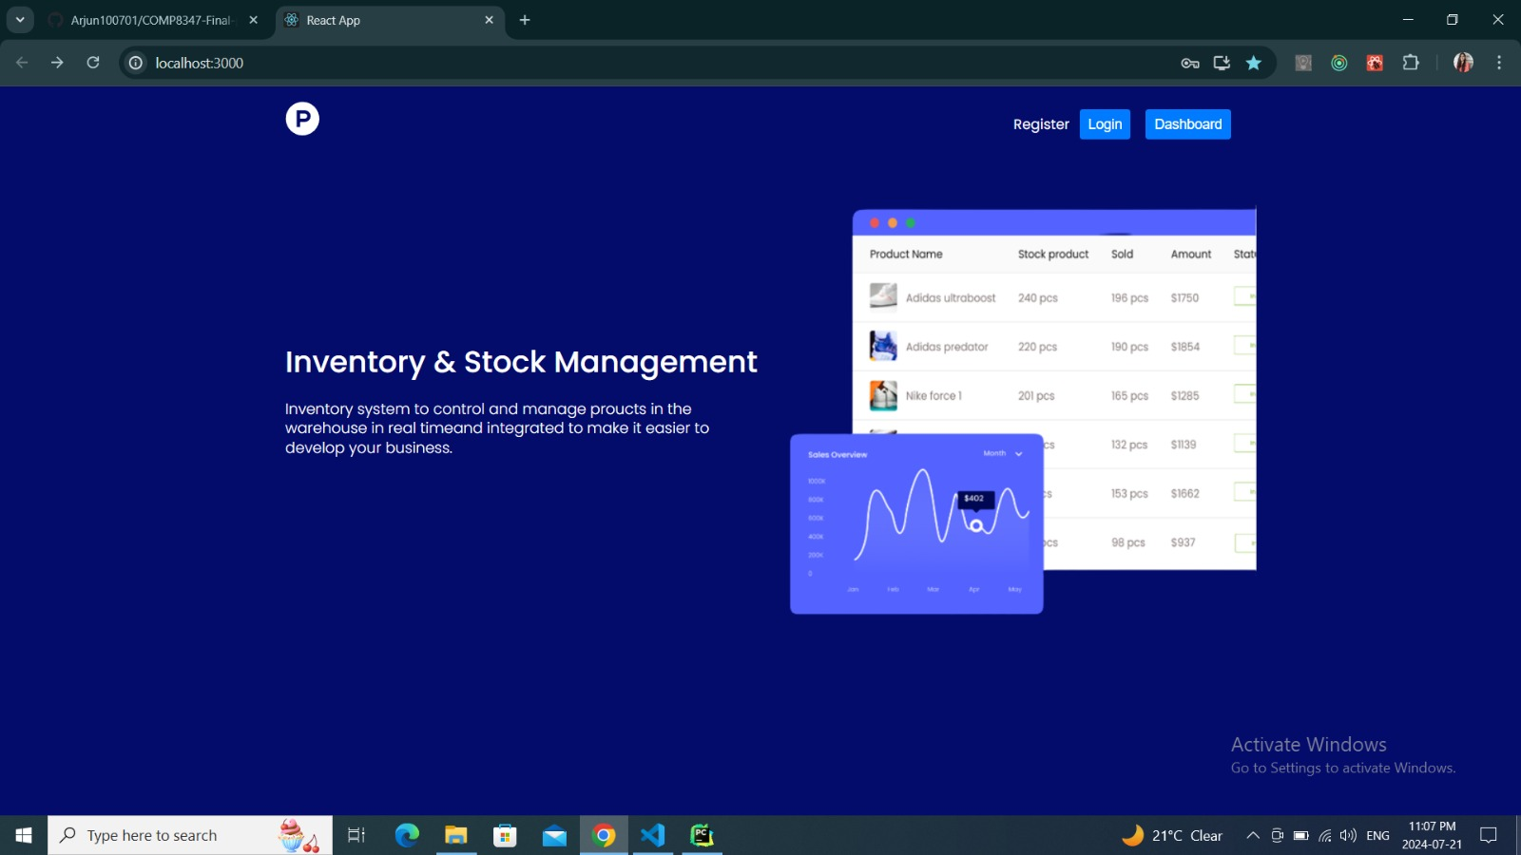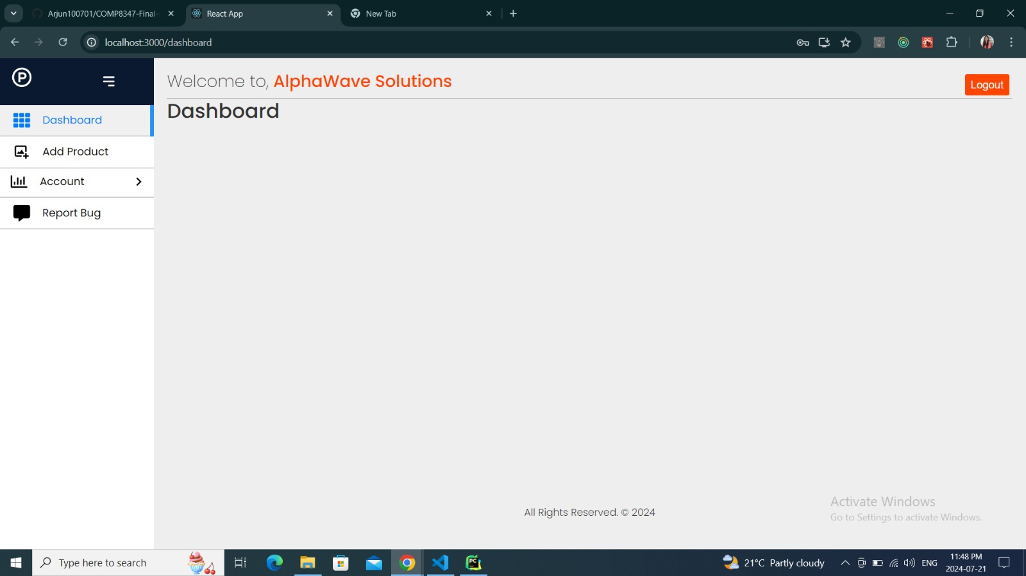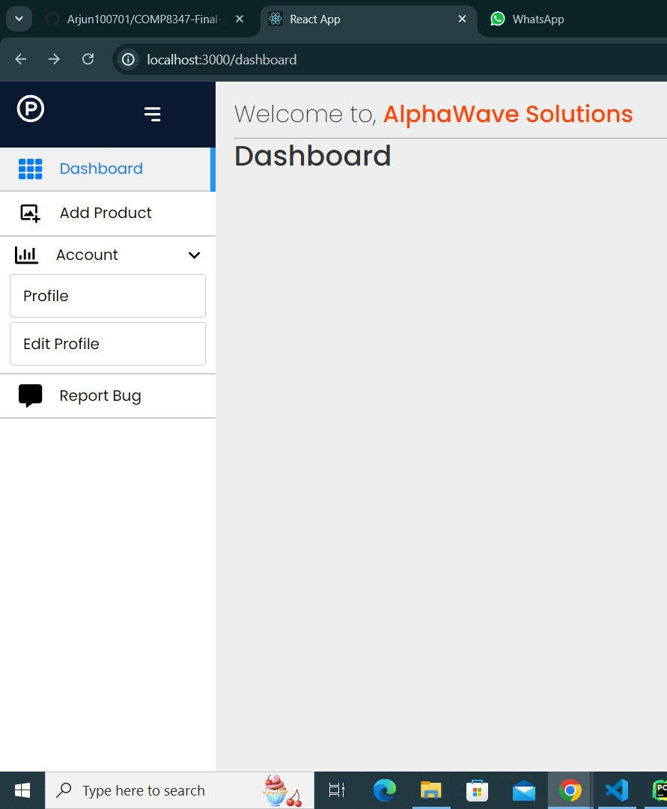

**Backend work done by Harsh ( in terms of commit history from git with patches and bug fixes done with respect to feedback received after testing from Baushil)**

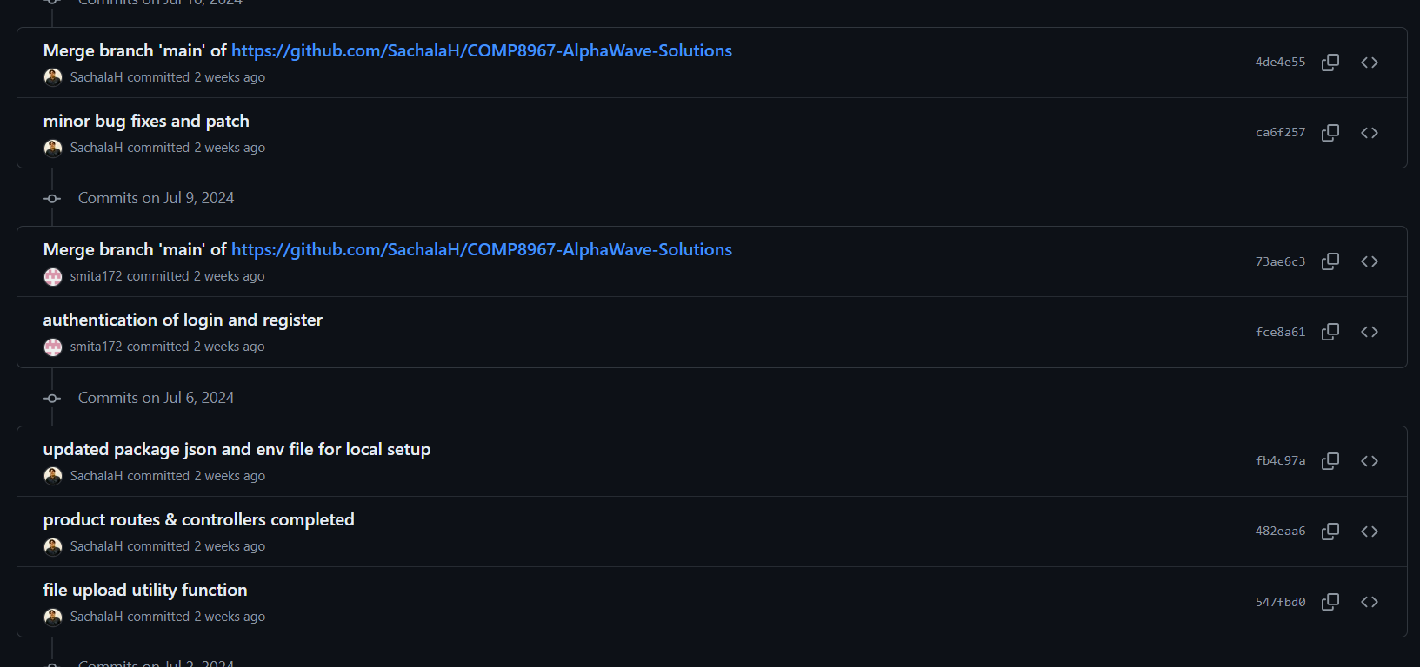

**Reports and API testing by Baushil**

